MAE Angora Kitten Questionnaire
Danielle Radey
702.704.4313
www.maeboerboel.com
maeangora@gmail.com
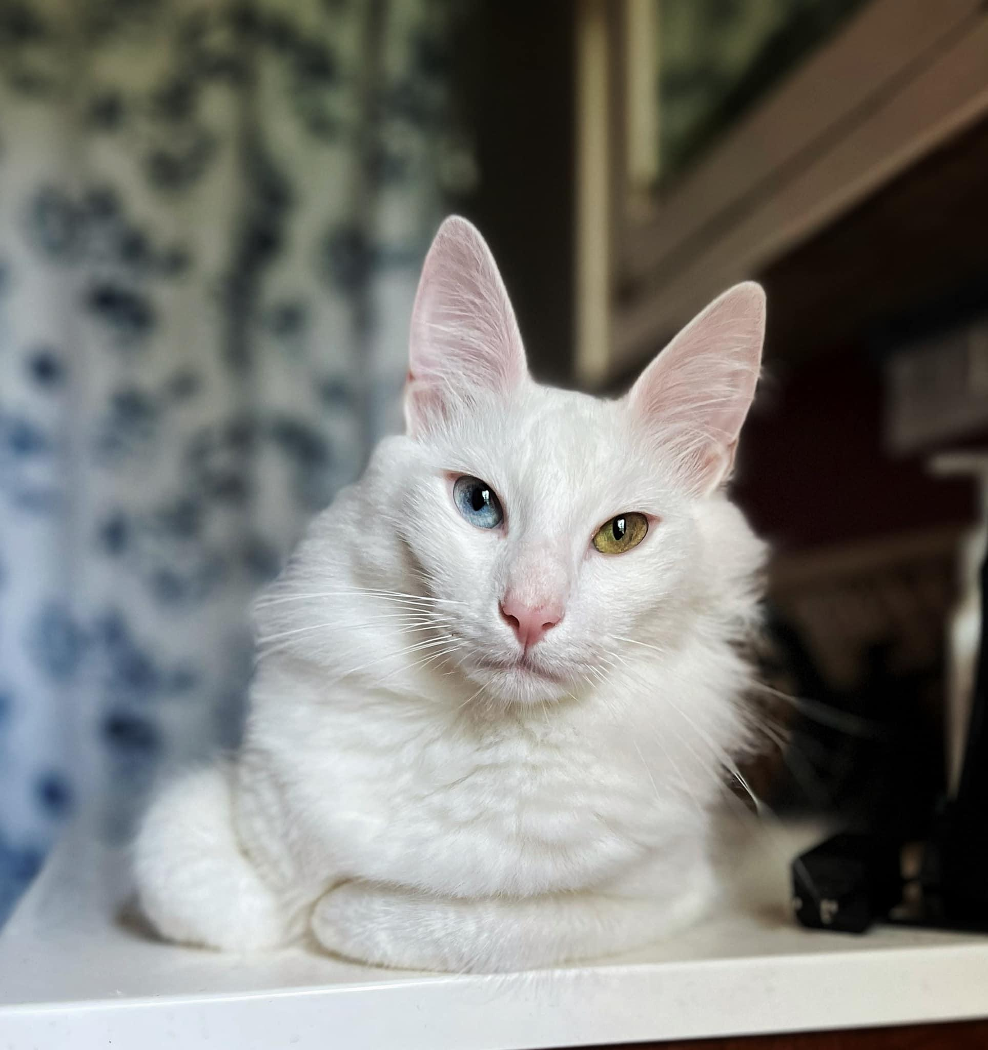
Thank you for inquiring about our kittens!
We take great pride in our Turkish Angoras! So we would like to understand your daily lifestyle to ensure we select your perfect new family member.
Our Goal here at MAE Angora is to produce a healthy, loving companion for you and your family!

FULL name of everyone in your household:
Address:
Phone #:
E-Mail:
Veterinary Clinic Information
Phone #:
Address:
The name of your actual Vet:

~ Do you own/rent your home?:
~ Do you have any other Cats (If yes, are they fixed and sex)?:
~ Do you own any other pets (If yes, please list)?:
~ Do you have any kids, (If yes, please list ages)?:
~ Is anyone allergic to cats?:
~ Do you live a very busy lifestyle?:

~ Why do you want a Turkish Angora?:

~ Do you want a male or female kitten?:
~ Do you wish to have a certain coat color?:
~ Do you want a certain eye color?:
~ What type of personality are you looking for in your TA?:
~ Would you ever give up your TA?:

~ Will you declaw the kitten?:
~ What type of food will you feed?:
(We recommend a brand that is located in most Feed Stores)
~ Will you feed kibble and wet food?:
~ Are you looking for a PET or BREEDING RIGHTS?:
~ How do you plan to pick your kitten up?:
(We provide a Flight Nanny Service for an extra charge)
~ Please let me know any other information you’d like me to know about your family:
Your kitten will come with a shot record, dewormed, microchipped, a health certificate and registered with TICA. We take great pride in each and every single kitten that is born here, with that said we want to be a part of the development throughout your cats life. We want to inform you on the proper feeding, supplements and exposure your kitten will need during these important stages. All of our Turkish Angoras are DNA tested with Optimal Selection and our kitten will come with our lifetime support!
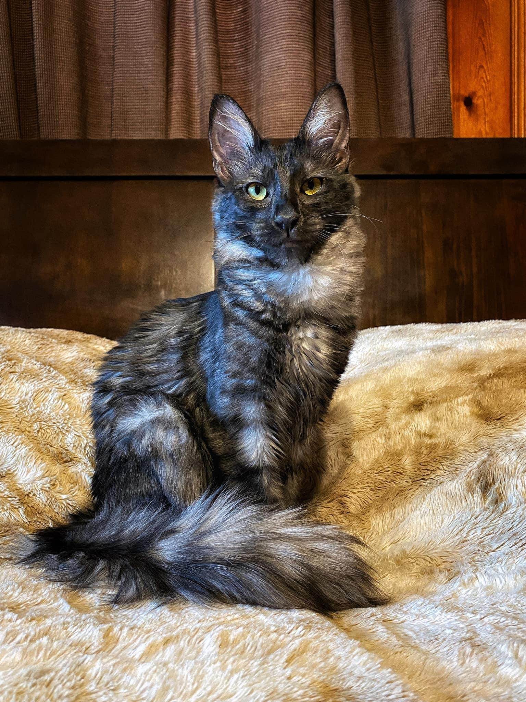
Please feel free to ask any questions that you may have regarding our Turkish Angora’s.
We look forward to speaking with you further!

